TC-CMS-006
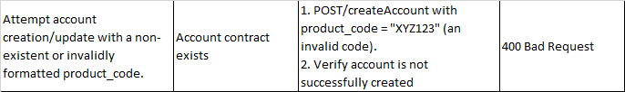
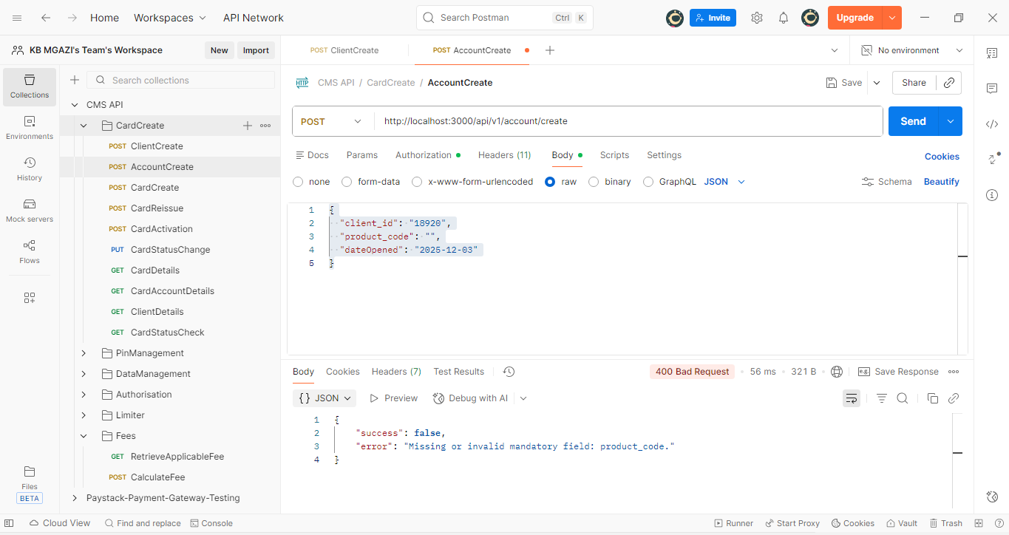
Request:
{
"client_id": "CL-18920",
"product_code": "",
"dateOpened": "2025-12-03"
}

Response:
{
"success": false,
"error": "Missing or invalid mandatory field: product_code."
}

